# Real Estate Price prediction¶

It plays a pivotal role in the real estate market and the broader economy. Accurate price predictions are essential for investors, developers, and homeowners, as they enable informed decision-making, strategic investment planning, and effective risk management.

The dataset provided comprises 414 entries, each containing detailed information about real estate transactions. It encompasses a range of features known to influence real estate pricing:

* Transaction date: Indicates the date of the property transaction.
* House age: Reflects the age of the property in years.
* Distance to the nearest MRT station: This factor is crucial for convenience and accessibility, measured in meters.
* Number of convenience stores: Represents the count of nearby convenience stores, which is indicative of the property's access to basic amenities.
* Latitude and Longitude: Geographical coordinates of the property, providing insight into its location.
* House price of unit area: The target variable, representing the house price per unit area.

The dataset is comprehensive, containing a combination of continuous and categorical variables. Importantly, it is devoid of missing values, rendering it robust for predictive modeling purposes.

The primary aim is to develop a predictive model capable of accurately forecasting the house price per unit area based on various features such as property age, proximity to key amenities (MRT stations and convenience stores), and geographical location.

In [62]:

import pandas as pd

The dataset comprises 7 columns, each providing specific information about real estate transactions. Here's a concise summary of each column:

1. **Transaction date**: This column records the date of the real estate transaction.
2. **House age**: Indicates the age of the house in years at the time of the transaction.
3. **Distance to the nearest MRT station**: Specifies the distance, in meters, from the property to the nearest Mass Rapid Transit (MRT) station. This metric is crucial for assessing convenience and accessibility.
4. **Number of convenience stores**: Represents the count of convenience stores located in the vicinity of the property. This factor is significant as it reflects the property's proximity to basic amenities.
5. **Latitude**: Provides the geographical coordinate of the property's location in terms of latitude. Latitude values denote the north-south position on the Earth's surface.
6. **Longitude**: Indicates the geographical coordinate of the property's location in terms of longitude. Longitude values denote the east-west position on the Earth's surface.
7. **House price of unit area**: This column specifies the price of the house per unit area, which is a key target variable for predictive modeling. It represents the price at which the property was sold per unit of its total area.

These columns collectively provide comprehensive information about each real estate transaction, facilitating analysis and modeling to predict house prices accurately.

In [63]:

# Display the first few rows of the dataset and the info about the dataset

real_estate_data_head = real_estate_data.head()

data_info = real_estate_data.info()

print(real_estate_data_head)

print(data_info)

<class 'pandas.core.frame.DataFrame'>

RangeIndex: 414 entries, 0 to 413

Data columns (total 7 columns):

# Column Non-Null Count Dtype

--- ------ -------------- -----

0 Transaction date 414 non-null object

1 House age 414 non-null float64

2 Distance to the nearest MRT station 414 non-null float64

3 Number of convenience stores 414 non-null int64

4 Latitude 414 non-null float64

5 Longitude 414 non-null float64

6 House price of unit area 414 non-null float64

dtypes: float64(5), int64(1), object(1)

memory usage: 22.8+ KB

Transaction date House age Distance to the nearest MRT station \

0 2012-09-02 16:42:30.519336 13.3 4082.0150

1 2012-09-04 22:52:29.919544 35.5 274.0144

2 2012-09-05 01:10:52.349449 1.1 1978.6710

3 2012-09-05 13:26:01.189083 22.2 1055.0670

4 2012-09-06 08:29:47.910523 8.5 967.4000

Number of convenience stores Latitude Longitude \

0 8 25.007059 121.561694

1 2 25.012148 121.546990

2 10 25.003850 121.528336

3 5 24.962887 121.482178

4 6 25.011037 121.479946

House price of unit area

0 6.488673

1 24.970725

2 26.694267

3 38.091638

4 21.654710

None

In [64]:

print(real_estate_data.isnull().sum())

Transaction date 0

House age 0

Distance to the nearest MRT station 0

Number of convenience stores 0

Latitude 0

Longitude 0

House price of unit area 0

dtype: int64

In [65]:

# Descriptive statistics of the dataset

descriptive_stats = real_estate_data.describe()

print(descriptive_stats)

House age Distance to the nearest MRT station \

count 414.000000 414.000000

mean 18.405072 1064.468233

std 11.757670 1196.749385

min 0.000000 23.382840

25% 9.900000 289.324800

50% 16.450000 506.114400

75% 30.375000 1454.279000

max 42.700000 6306.153000

Number of convenience stores Latitude Longitude \

count 414.000000 414.000000 414.000000

mean 4.265700 24.973605 121.520268

std 2.880498 0.024178 0.026989

min 0.000000 24.932075 121.473888

25% 2.000000 24.952422 121.496866

50% 5.000000 24.974353 121.520912

75% 6.750000 24.994947 121.544676

max 10.000000 25.014578 121.565321

House price of unit area

count 414.000000

mean 29.102149

std 15.750935

min 0.000000

25% 18.422493

50% 30.394070

75% 40.615184

max 65.571716

In [66]:

import matplotlib.pyplot as plt

import seaborn as sns

In [67]:

# Set the aesthetic style of the plots

sns.set_style("whitegrid")

##### The histograms provide valuable insights into the distribution of each variable:¶

1. **House Age**: The distribution appears relatively uniform, with a slight increase in the number of newer properties (lower age), suggesting a diverse range of property ages within the dataset.
2. **Distance to the Nearest MRT Station**: Most properties are situated in close proximity to an MRT station, evidenced by the high frequency of lower distances. However, there is a long tail extending towards higher distances, indicating the presence of properties located farther away from MRT stations.
3. **Number of Convenience Stores**: This histogram displays a wide range of counts, with notable peaks at specific counts such as 0, 5, and 10 convenience stores. This pattern suggests common configurations regarding the availability of convenience stores near the properties.
4. **Latitude and Longitude**: Both distributions show concentrations, indicating that the properties are situated within a limited geographic area. This suggests that the dataset encompasses properties located in a specific region.
5. **House Price of Unit Area**: The histogram reveals a right-skewed distribution, with a concentration of properties in the lower price range and fewer properties as prices increase. This distribution pattern highlights the variability in property prices within the dataset, with a notable number of properties priced at the lower end.

In [68]:

# Create histograms for the numerical columns

fig, axes = plt.subplots(nrows=3, ncols=2, figsize=(12, 12))

fig.suptitle('Histograms of Real Estate Data', fontsize=16)

cols = ['House age', 'Distance to the nearest MRT station', 'Number of convenience stores',

'Latitude', 'Longitude', 'House price of unit area']

for i, col in enumerate(cols):

sns.histplot(real_estate_data[col], kde=True, ax=axes[i//2, i%2])

axes[i//2, i%2].set_title(col)

axes[i//2, i%2].set_xlabel('')

axes[i//2, i%2].set_ylabel('')

plt.tight_layout(rect=[0, 0.03, 1, 0.95])

plt.show()

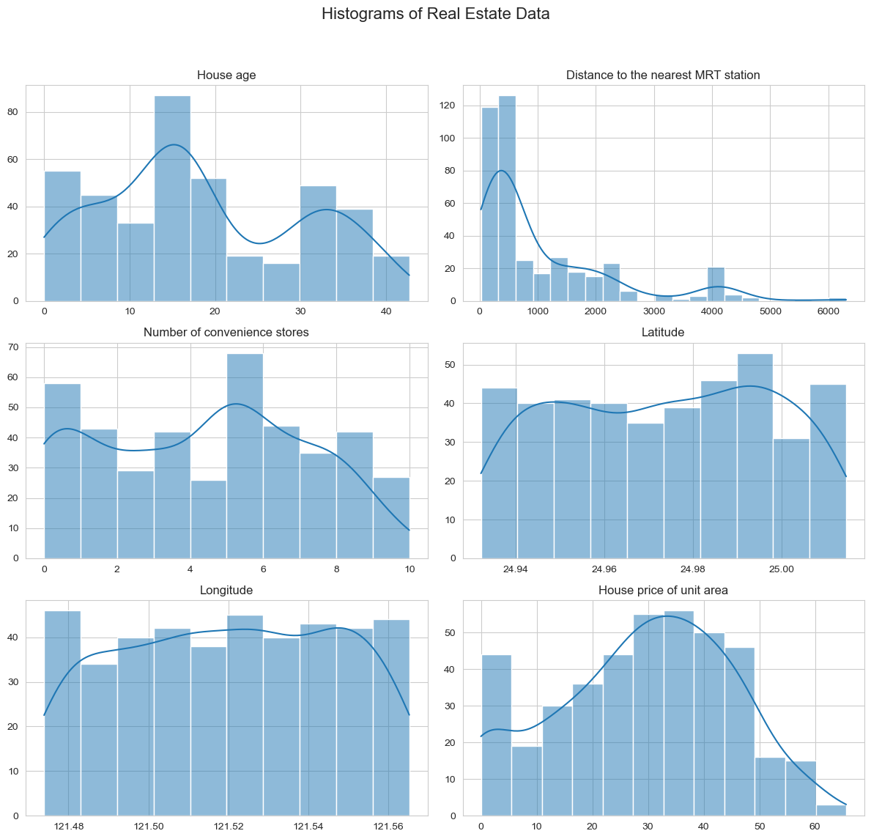

##### The scatter plots revealed intriguing relationships between various factors and house prices:¶

1. **House Age vs. House Price**: No strong linear relationship is evident between house age and price. However, there appears to be a trend where very new and very old houses might command higher prices.
2. **Distance to the Nearest MRT Station vs. House Price**: A clear trend emerges, indicating that as the distance to the nearest MRT station increases, house prices tend to decrease. This observation suggests a strong negative relationship between these two variables.
3. **Number of Convenience Stores vs. House Price**: A positive relationship seems to exist between the number of convenience stores and house prices. Properties located in areas with more convenience stores nearby tend to have higher prices.
4. **Latitude vs. House Price**: While not demonstrating a strong linear relationship, there appears to be a discernible pattern where certain latitudes correspond to higher or lower house prices. This pattern might reflect the desirability of specific neighborhoods or locations.

In [69]:

# Scatter plots to observe the relationship with house price

fig, axes = plt.subplots(nrows=2, ncols=2, figsize=(12, 10))

fig.suptitle('Scatter Plots with House Price of Unit Area', fontsize=16)

# Scatter plot for each variable against the house price

sns.scatterplot(data=real_estate_data, x='House age', y='House price of unit area', ax=axes[0, 0])

sns.scatterplot(data=real_estate_data, x='Distance to the nearest MRT station', y='House price of unit area', ax=axes[0, 1])

sns.scatterplot(data=real_estate_data, x='Number of convenience stores', y='House price of unit area', ax=axes[1, 0])

sns.scatterplot(data=real_estate_data, x='Latitude', y='House price of unit area', ax=axes[1, 1])

plt.tight_layout(rect=[0, 0.03, 1, 0.95])

plt.show()

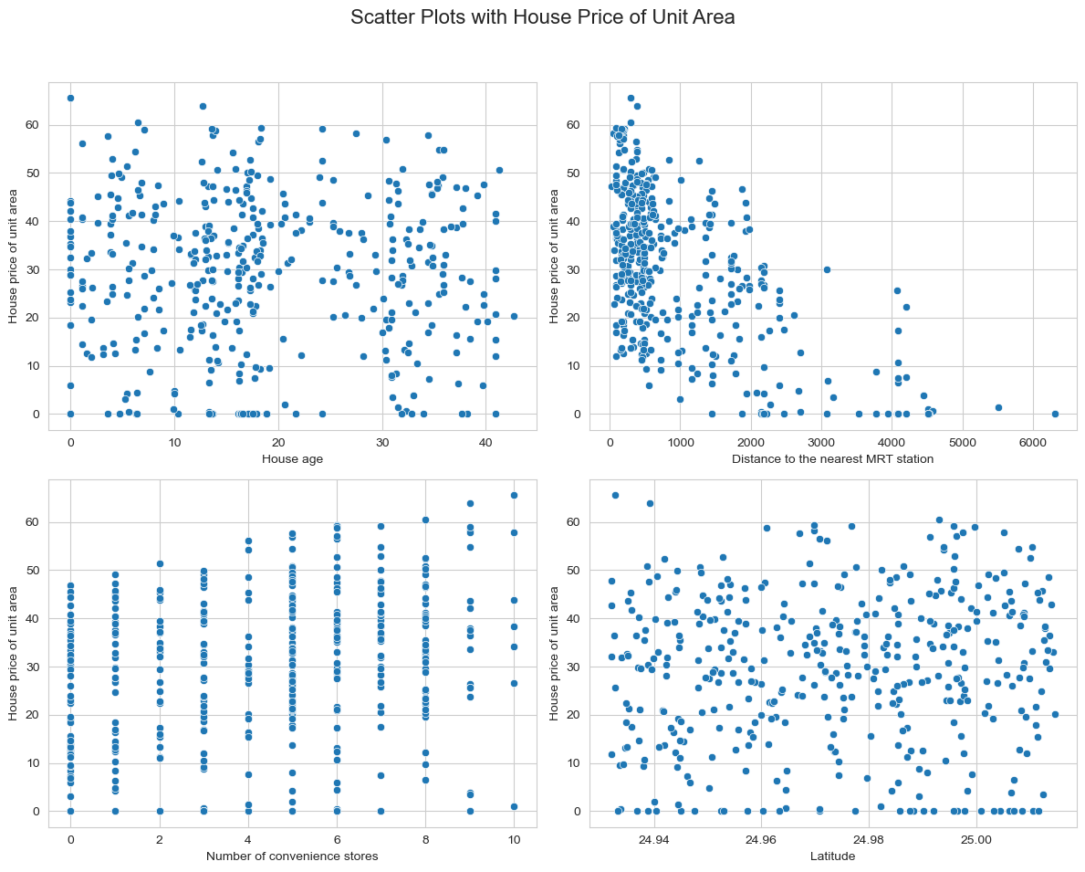

The correlation matrix offers quantified insights into the relationships between each variable, particularly concerning house prices:

1. **House Age**: Exhibits a very weak negative correlation with house price (-0.012), suggesting that age is not a strong predictor of price in this dataset.
2. **Distance to Nearest MRT Station**: Demonstrates a strong negative correlation with house price (-0.637). This implies that properties closer to MRT stations tend to command higher prices, underscoring the significance of proximity to public transportation in property valuation.
3. **Number of Convenience Stores**: Shows a moderate positive correlation with house price (0.281). The presence of more convenience stores in the vicinity appears to positively influence property prices.
4. **Latitude and Longitude**: Both variables display weak correlations with house prices. Latitude exhibits a slight positive correlation (0.081), whereas longitude has a slight negative correlation (-0.099).

Overall, the most influential factors impacting house prices in this dataset are the proximity to MRT stations and the number of convenience stores nearby. Geographic location (latitude and longitude) and the age of the house appear to have relatively less impact on property prices.

In [70]:

# Correlation matrix

correlation_matrix = real_estate_data.corr()

# Plotting the correlation matrix

plt.figure(figsize=(10, 6))

sns.heatmap(correlation_matrix, annot=True, cmap='coolwarm', fmt=".2f", linewidths=.5)

plt.title('Correlation Matrix')

plt.show()

print(correlation_matrix)

C:\Users\anike\AppData\Local\Temp\ipykernel_13536\853538187.py:2: FutureWarning:

The default value of numeric_only in DataFrame.corr is deprecated. In a future version, it will default to False. Select only valid columns or specify the value of numeric_only to silence this warning.

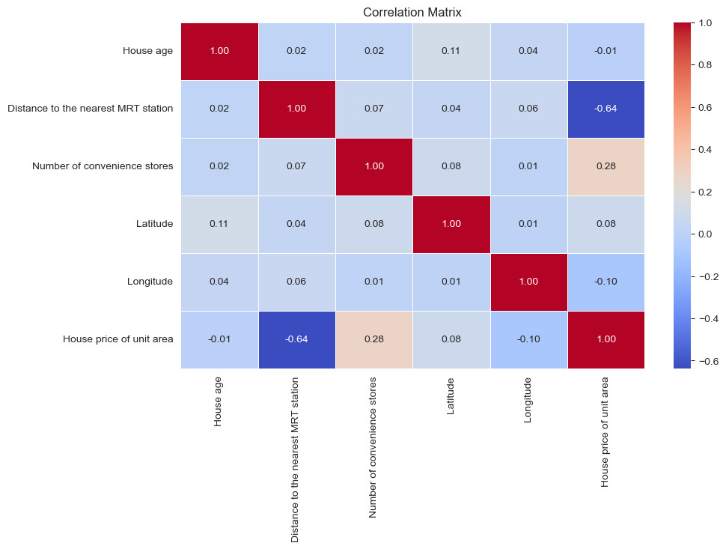

House age \

House age 1.000000

Distance to the nearest MRT station 0.021596

Number of convenience stores 0.021973

Latitude 0.114345

Longitude 0.036449

House price of unit area -0.012284

Distance to the nearest MRT station \

House age 0.021596

Distance to the nearest MRT station 1.000000

Number of convenience stores 0.069015

Latitude 0.038954

Longitude 0.064229

House price of unit area -0.636579

Number of convenience stores Latitude \

House age 0.021973 0.114345

Distance to the nearest MRT station 0.069015 0.038954

Number of convenience stores 1.000000 0.082725

Latitude 0.082725 1.000000

Longitude 0.013156 0.007754

House price of unit area 0.280763 0.081008

Longitude House price of unit area

House age 0.036449 -0.012284

Distance to the nearest MRT station 0.064229 -0.636579

Number of convenience stores 0.013156 0.280763

Latitude 0.007754 0.081008

Longitude 1.000000 -0.098626

House price of unit area -0.098626 1.000000

In [71]:

from sklearn.model_selection import train_test_split

from sklearn.linear_model import LinearRegression

from sklearn.metrics import mean_squared_error, r2_score

In [72]:

# Selecting features and target variable

features = ['Distance to the nearest MRT station', 'Number of convenience stores', 'Latitude', 'Longitude']

target = 'House price of unit area'

In [73]:

X = real_estate_data[features]

y = real_estate_data[target]

In [74]:

# Splitting the dataset into training and testing sets

X_train, X_test, y_train, y_test = train_test_split(X, y, test_size=0.2, random_state=42)

In [75]:

# Model initialization

model = LinearRegression()

In [76]:

# Training the model

model.fit(X_train, y_train)

Out[76]:

LinearRegression()

**In a Jupyter environment, please rerun this cell to show the HTML representation or trust the notebook.   
On GitHub, the HTML representation is unable to render, please try loading this page with nbviewer.org.**

LinearRegression

LinearRegression()

A clear interpretation of the scatter plot representing the model's predictions. It effectively communicates the following observations:

1. **Proximity to Diagonal Line**: Many points are close to the diagonal line, indicating that the model makes reasonably accurate predictions for a substantial portion of the test set. This suggests that the model performs well in predicting house prices accurately in certain instances.
2. **Deviation from Diagonal Line**: Some points are further from the diagonal line, highlighting areas where the model's predictions deviate more significantly from the actual values. These deviations may signify instances where the model struggles to accurately predict house prices, possibly due to complexities or outliers in the data.

The conclusion succinctly summarizes the process of predicting real estate prices using machine learning with Python. Overall, the explanation provides a concise overview of the predictive modeling process and its implications for real estate price prediction.

In [77]:

# Making predictions using the linear regression model

y_pred_lr = model.predict(X_test)

# Visualization: Actual vs. Predicted values

plt.figure(figsize=(10, 6))

plt.scatter(y_test, y_pred_lr, alpha=0.5)

plt.plot([y_test.min(), y_test.max()], [y_test.min(), y_test.max()], 'k--', lw=2)

plt.xlabel('Actual')

plt.ylabel('Predicted')

plt.title('Actual vs. Predicted House Prices')

plt.show()

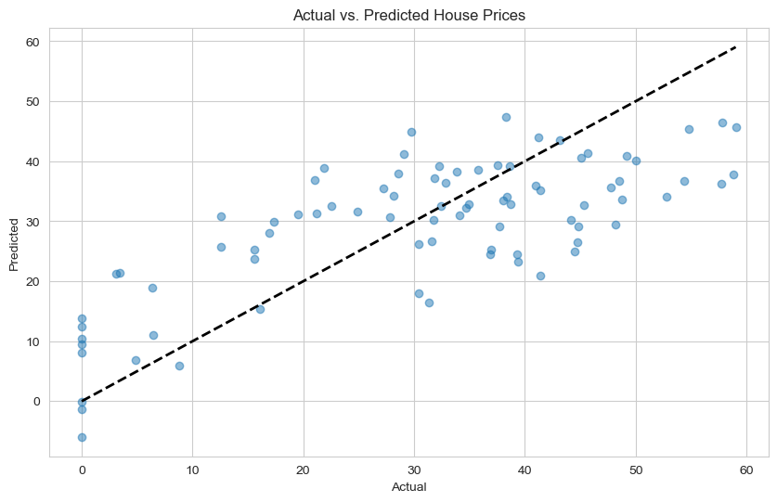

###### Dash is an open-source Python framework used for building interactive web applications. It's particularly popular for creating analytical and data visualization applications due to its integration with popular data science libraries like Plotly and Pandas.¶

###### In this code snippet:¶

Dash is the main Dash library. html and dcc (Dash Core Components) are used to create HTML and interactive components. Input, Output, and State are used for creating callbacks in Dash, enabling interactivity.

In [78]:

import dash

from dash import html, dcc, Input, Output, State

import pandas as pd

Dash simplifies the process of creating web-based data applications in Python, enabling developers and data scientists to focus on building rich and interactive user experiences without having to delve deeply into web development technologies.

In [79]:

# Initialize the Dash app

app = dash.Dash(__name__)

Here, we define the HTML structure of the app using Dash’s HTML components. The layout includes a title (html.H1), input fields for distance to the MRT station, number of convenience stores, latitude, and longitude (dcc.Input), and a button to trigger the prediction (html.Button).

In [80]:

# Define the layout of the app

app.layout = html.Div([

html.Div([

html.H1("Real Estate Price Prediction", style={'text-align': 'center'}),

html.Div([

dcc.Input(id='distance_to_mrt', type='number', placeholder='Distance to MRT Station (meters)',

style={'margin': '10px', 'padding': '10px'}),

dcc.Input(id='num_convenience_stores', type='number', placeholder='Number of Convenience Stores',

style={'margin': '10px', 'padding': '10px'}),

dcc.Input(id='latitude', type='number', placeholder='Latitude',

style={'margin': '10px', 'padding': '10px'}),

dcc.Input(id='longitude', type='number', placeholder='Longitude',

style={'margin': '10px', 'padding': '10px'}),

html.Button('Predict Price', id='predict_button', n_clicks=0,

style={'margin': '10px', 'padding': '10px', 'background-color': '#007BFF', 'color': 'white'}),

], style={'text-align': 'center'}),

html.Div(id='prediction_output', style={'text-align': 'center', 'font-size': '20px', 'margin-top': '20px'})

], style={'width': '50%', 'margin': '0 auto', 'border': '2px solid #007BFF', 'padding': '20px', 'border-radius': '10px'})

])

This is a callback function that updates the output (prediction result) when the ‘Predict Price’ button is clicked. Output('prediction_output', 'children') indicates that the inner content (children) of the component with id prediction_output will be updated by this callback.

The callback takes the number of button clicks as Input and the values of the four input fields as State. The function update_output is executed when the button is clicked, using the input values to generate a prediction.

Inside the update_output function, the inputs are first checked to ensure they are not None. The inputs are then arranged into a Pandas DataFrame, matching the expected format for the model. The model.predict method is called to generate a prediction. This assumes that a trained model named model exists and is accessible within this script. The function returns either the predicted price or a prompt to enter all values.

In [81]:

# Define callback to update output

@app.callback(

Output('prediction_output', 'children'),

[Input('predict_button', 'n_clicks')],

[State('distance_to_mrt', 'value'),

State('num_convenience_stores', 'value'),

State('latitude', 'value'),

State('longitude', 'value')]

)

def update_output(n_clicks, distance_to_mrt, num_convenience_stores, latitude, longitude):

if n_clicks > 0 and all(v is not None for v in [distance_to_mrt, num_convenience_stores, latitude, longitude]):

# Prepare the feature vector

features = pd.DataFrame([[distance_to_mrt, num_convenience_stores, latitude, longitude]],

columns=['distance_to_mrt', 'num_convenience_stores', 'latitude', 'longitude'])

# Predict

prediction = model.predict(features)[0]

return f'Predicted House Price of Unit Area: {prediction:.2f}'

elif n_clicks > 0:

return 'Please enter all values to get a prediction'

return ''

This part runs the app server when the script is executed directly (**name** == '**main**'). debug=True enables the debug mode, which provides an interactive debugger in the browser and auto-reloads the server on code changes.

In [82]:

# Run the app

if __name__ == '__main__':

app.run_server(debug=True)

##### Conclusion¶

Real Estate Price Prediction, within the realm of Machine Learning, entails the task of using algorithms and statistical techniques to estimate or forecast the future prices of real estate properties, encompassing various types such as houses, apartments, or commercial buildings. The primary objective is to furnish accurate property rates to buyers, sellers, investors, and real estate professionals, enabling them to make well-informed decisions regarding real estate transactions. Employing Python for this purpose allows for the utilization of robust libraries and frameworks for data processing, model building, and predictive analysis. By leveraging Machine Learning algorithms, predictive models can be trained on historical real estate data to discern patterns and relationships among different features, ultimately yielding predictions of future property prices. This prediction provids an overview of the Real Estate Price Prediction process with Machine Learning using Python, elucidating the significance of accurate predictions in the real estate market. Feel free to pose any insightful inquiries or share thoughts in the comments section below, fostering a collaborative discourse on this intriguing domain.